

SMART PARKING
TEAM MEMBER
732721106034 : SATHYA.R
PHASE 4 SUBMISSION DOCUMENT
PROJECT : SMART PARKING
This document presents an innovative solution to enhance the efficiency and reliability of smart parking systems by incorporating predictive maintenance algorithms. By utilizing sensor data and advanced algorithms, our solution aims to anticipate maintenance needs, reduce downtime, and improve overall user experience.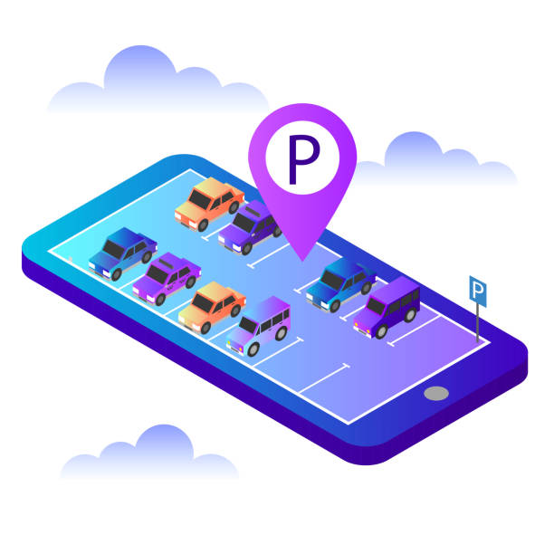
INTRODUCTION:
Smart parking systems have revolutionized urban mobility by optimizing parking space usage and enhancing convenience. However, they are susceptible to equipment failures, causing disruptions and inconvenience to users. To address this issue, we propose the integration of predictive maintenance algorithms, which can anticipate potential maintenance requirements before they lead to system failures.
Prerequisites:
Install Flutter: Make sure you have Flutter installed on your development machine. You can follow the official Flutter installation guide for this.
Steps to Develop the Mobile App:

1. Set Up Your Project:
Create a new Flutter project using the Flutter CLI. Navigate to your desired directory and run:
bash
Copy code
flutter create smart_parking_app
cd smart_parking_app
2. Add Dependencies:
You will need to add dependencies to your pubspec.yaml file. You'll likely need packages for networking (to receive data from the Raspberry Pi) and for displaying data in a user-friendly way. For example, you might use packages like http for making API requests and flutter_bloc for state management.
yaml
Copy code
dependencies:
flutter:
sdk: flutter
http: ^0.13.3
flutter_bloc: ^7.0.0
# Add other dependencies as needed
After adding the dependencies, run flutter pub get to fetch and install them.

3. Create UI:
Design the user interface of your app. You can use Flutter's widget-based approach to create your UI. For this smart parking app, you might have a screen that displays a list of parking spots with real-time availability information.

4. Networking:
You need to set up networking to communicate with the Raspberry Pi or the server where real-time parking data is stored. You can use the http package for this. Here's a simplified example of how to make an HTTP GET request:

dart
Copy code
import 'package:http/http.dart' as http;

Future<Map<String, dynamic>> fetchParkingData() async {
final response = await http.get(Uri.parse('your_parking_data_api_url'));
if (response.statusCode == 200) {
return json.decode(response.body);
} else {
throw Exception('Failed to load parking data');
}
}
5. State Management:
You can use the flutter_bloc package or another state management solution to handle the application's state. Create a bloc to manage the parking availability data and update the UI accordingly when new data is received.

6. Real-time Updates:
To display real-time parking availability, you'll need to continuously poll the server for updates. You can achieve this using periodic API requests, WebSockets, or another real-time communication method.

7. Display Data:
your UI to display the parking availability data received from the Raspberry Pi. You can use widgets like ListView or GridView to present the parking spots, and update their status as new data arrives.

8. Test on Devices:
Test your app on both Android and iOS devices. You can use simulators/emulators or real devices for testing.
9. Deployment:
Once your app is complete and thoroughly tested, you can deploy it to the Google Play Store for Android and the Apple App Store for iOS.

